Note: I just include images for reference – please size to however they look best as usual]

Week of July 1, 2013

NEW SECTION
PHYSICIANS SPOTLIGHT:
New Physicians Join FHMG
A leader in comprehensive digestive and liver care, Central Florida Hepatology & Gastroenterology is proud to welcome two new physicians to their team. Ilan Aharoni, MD and Irteza B. Inayat, MD join Dr. Kashi and Dr. Cortes to help expand the practice’s GI diagnostic capabilities in handling the growing number of gastroenterology cases in Central Florida. 407.303.1812
Please welcome our newest physicians as FHMG continues to grow and broaden its medical presence in Central Florida.
[Include headshot of Ilan Aharoni, MD]
Ilan Aharoni, MD
Central Florida Hepatology & Gastroenterology

Dr. Aharoni is board certified in gastroenterology and internal medicine, and fellowship trained in gastroenterology. He completed his residency, along with his fellowship, at Maimonides Medical Center in Brooklyn, NY, where he was named Chief Resident. Dr. Aharoni has special interest in the treatment of chronic liver disease and advanced colorectal neoplasm using EMR technique and RadioFrequency Ablation of Barrett's Esophagus.

Include headshot of Irteza B. Inayat, MD]
Irteza B. Inayat, MD
Central Florida Hepatology & Gastroenterology

Dr. Inayat is board certified in gastroenterology and internal medicine, and fellowship trained in gastroenterology, hepatology and ERCP. He completed his residency, along with an extensive fellowship, at Yale University School of Medicine, where he received the coveted John W. Brackett Residency Teacher of the Year Award. He specializes in the treatment of chronic liver disease and advanced colorectal neoplasm using EMR technique and RadioFrequency Ablation of Barrett's Esophagus.

NEW SECTION

Header:
Reminder: HR Benefits Update
[Include stock icon – thinkstock # 153700861]

Copy:
Important Information on Dependent Eligibility Verification
Florida Hospital and FHMG, as part of Adventist Health System (AHS), is currently working with our health benefits consultant, Mercer, to conduct a verification program of dependent eligibility. Because the health plan premiums are shared, having non-eligible dependents on the Plan increases costs for employees and the employer. Conducting a periodic review is a way to ensure that the health plan is being properly used by all employees. By now, you should have received an envelope from Mercer with information about the DEV program. Do not discard it. The envelope contains personalized instructions to gain access to the DEV website and instructions regarding the documentation needed to verify the eligibility status of dependents on the Health Plan. Be sure to fill it out and send it in by July 17. If you do not receive the packet, please call the Mercer hotline at 800.893.3540.

Please download this helpful PDF for current Mercer DEV website issues [link to “Mercer Packet Issues” PDF]

NEW SECTION

Header:
Improving Our Employee Orientation
[Include shot of the RDV – like the one below]

Copy:
New employees will be treated to more engagement in a brand new location, thanks to feedback from current employees at all levels across FHMG. The Human Resources team in partnership with the Customer Experience team has worked diligently to update and streamline the employee orientation process, combining the ONE customer training with each session and moving the whole event right next door to the RDV SportsPlex. There, new employees will be able to learn about FHMG through more interactive, hands-on activities in a dynamic environment, complete with breakfast and lunch.

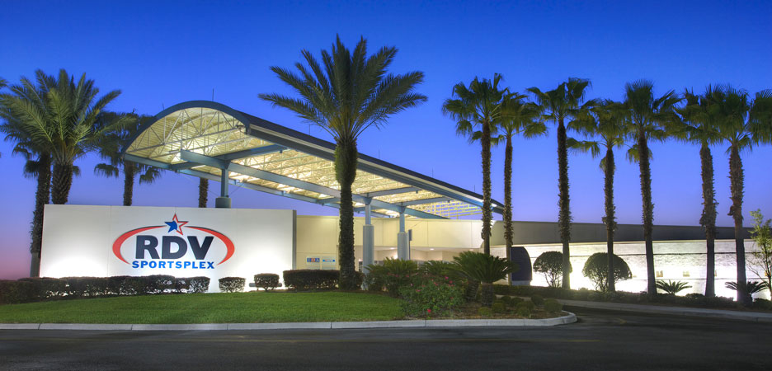

NEW SECTION

Header:
Center of Nutritional Excellence Provides a Healthy Resource
Copy:
If you’re searching for a great resource on nutrition and lifestyle counseling, look no further. All FHMG providers can turn to excellence in outpatient nutritional counseling at the Center of Nutritional Excellence (CNE). With convenient locations in Orlando, Altamonte Springs, East Orlando, and Winter Park, CNE is an excellence source for patients that need guidance on healthier nutrition and lifestyle recommendations. The comprehensive team of registered, licensed dieticians offers specialized counseling for both adults and children, on a variety of concerns, including:

Hypercholesterolemia
Hypertension
Failure to thrive
Digestive diseases
Food allergies (adults/pediatrics)
Cancer
Tube feedings
Weight loss (adults/pediatrics)

Download the PDF on Center of Nutritional Excellence or call 407.303.8157 to learn more.
[link underlined to PDF – need to edit PDF/just use the first page/the second and third are the same information, just different images, colors, etc.]

NEW SECTION
Header:
Focus Archives on FHMG Intranet

Copy:
Just a reminder for all new employees, if you missed an issue of our newsletter, you can find them archived on the FHMG Intranet. Please visit the link below to access past issues of the Focus.
https://drupal02.floridahospital.org/fpmg/content/news [please include actual link and link the image to the URL as well – so it’s clickable]

